Shivabasamma Beli

Shivabasamma Beli - IEEE_Conference_Template 1_ (7).pdf
 Quick Submit  Quick Submit
 Presidency University

Document Details

Submission ID trn:oid:::1:3407525360

7 Pages

4,889 Words

28,945 Characters
Submission Date
Nov 12, 2025, 9:46 AM GMT+5:30

Download Date
Nov 12, 2025, 10:33 AM GMT+5:30

File Name IEEE_Conference_Template

17.pdf

File Size
233.8 KB

*% detected as AI

Caution: Review required.
It is essential to understand the limitations of AI detection before making decisions about a student’s work. We encourage you to learn more about Turnitin’s AI detection capabilities before using the tool.
AI detection includes the possibility of false positives. Although some text in this submission is likely AI generated, scores below the 20% threshold are not surfaced because they have a higher likelihood of false positives.

Disclaimer
Our AI writing assessment is designed to help educators identify text that might be prepared by a generative AI tool. Our AI writing assessment may not always be accurate (i.e., our AI models may produce either false positive results or false negative results), so it should not be used as the sole basis for adverse actions against a student. It takes further scrutiny and human judgment in conjunction with an organization's application of its specific academic policies to determine whether any academic misconduct has occurred.

Frequently Asked Questions


How should I interpret Turnitin's AI writing percentage and false positives?
The percentage shown in the AI writing report is the amount of qualifying text within the submission that Turnitin’s AI writing detection model determines was either likely AI-generated text from a large-language model or likely AI-generated text that was likely revised using an AI paraphrase tool or word spinner.

False positives (incorrectly flagging human-written text as AI-generated) are a possibility in AI models.

AI detection scores under 20%, which we do not surface in new reports, have a higher likelihood of false positives. To reduce the likelihood of misinterpretation, no score or highlights are attributed and are indicated with an asterisk in the report (*%).

The AI writing percentage should not be the sole basis to determine whether misconduct has occurred. The reviewer/instructor should use the percentage as a means to start a formative conversation with their student and/or use it to examine the submitted assignment in accordance with their school's policies.

What does 'qualifying text' mean?
Our model only processes qualifying text in the form of long-form writing. Long-form writing means individual sentences contained in paragraphs that make up a longer piece of written work, such as an essay, a dissertation, or an article, etc. Qualifying text that has been determined to be likely AI-generated will be highlighted in cyan in the submission, and likely AI-generated and then likely AI-paraphrased will be highlighted purple.

Non-qualifying text, such as bullet points, annotated bibliographies, etc., will not be processed and can create disparity between the submission highlights and the percentage shown.

Agentless Windows System Vulnerability And Network Scanner

1st Gurram Sri Vishnu Mallik
Dept. of SOCSE Presidency University
vishnugurram7780@gmail.com

2ndCharan Sri Abhinay Dandamudi
Dept. of SOCSE Presidency University
abhinaydandamudi@gmail.com

3rd Arumalla Sai Babu Reddy
Dept. of SOCSE Presidency University
sai.arumalla04@gmail.com

4th Shivabasamma Beli Assistant Professor.Dept. of SOCSE Presidency University
shivabasamma.b@presidencyuniversity.in

5th Geeta Arjunan
Associate Professor.Dept. of SOCSE Presidency University Geetha669811@gmail.com

Abstract—The growing complexity of modern IT infrastruc- tures and the proliferation of sophisticated cyber threats made ro- bust vulnerability management an imperative for security. Agent- based scan products, while robust, are accompanied by associated operational overhead, performance burden, and deployment complexity, particularly in large or heterogenous environments. This is the architecture and implementation of an innovative, agentless network and vulnerability scanner specifically targeted at Windows platforms.
Our research avoids the limitations of conventional approaches by leveraging native Windows management protocols such as Windows Management Instrumentation (WMI) and PowerShell to scan system accurately without installation of any software or agents on the target hosts. The scanner has the ability to remotely scan system details, installed applications, security settings, and active network services. Comparing this information with a cur- rent vulnerability database, our application can determine and rank probably security vulnerabilities, for instance, unpatched packages, misconfiguration, and open ports. Our approach was to create a lightweight, command-line interface (CLI) application that can do multihost parallel scanning.
Our evaluation confirms that the agentless scanner provides an accurate and thorough security posture report with min- imal network performance overhead. The result is significant reduction of deployment friction and improved visibility into the network attack surface over agent-based options. This effort is a useful contribution to effective, real-world, and scalable risk management for network engineers and security professionals to actively secure their Windows infrastructure. ???
Index Terms—Vulnerability Management, Agentless Scan- ning, Network Security ,Windows Management Instrumentation (WMI), PowerShell, Risk Management, Security Assessment, Network Scanning.

- Introduction
The increased sophistication of contemporary IT infrastruc- ture and the spread of advanced cyber threats have rendered effective vulnerability management a necessity in security. While providing extensive system visibility, traditional agent- based scanning solutions are frequently accompanied by large operational overhead, high performance impact, and high de- ployment complexity, especially in large or complex environ- ments. This paper introduces the architecture, implementation,
and testing of a new, agentless network and vulnerability scanner tailored to the Windows platform. Our approach takes advantage of native Windows management protocols to offer a non-intrusive yet complete means of evaluating the security posture of an organization’s Windows infrastructure with minimal friction versus traditional solutions.
- Background and Motivation
An active risk management approach is the foundation of effective cybersecurity. Scanning for vulnerabilities is a central part of this, an automated process of discovering and listing and security vulnerabilities. Two dominant methodologies have long occupied the marketplace: agent-based and network- based scanning. Agent-based approaches include the installa- tion of a software client onto every endpoint, which proceeds to scan locally and communicate with a central server. Gran- ular control and thorough insight into the systems are benefits of this methodology, but huge problems are presented. These consist of the weight of dealing with thousands of agents, possible interference with other software, and slowing down host systems. Network scanners, however, scan from a single location but tend to lack depth in identifying misconfigurations or unpatched applications that are not exposed on the network. This work is motivated by the desire for a hybrid that brings together the deep-level understanding of agent-based systems with the low-overhead, scalable characteristics of network- based scanning.
- Problem Statement
There’s a trade-off between ease of deployment and quality of scan where legacy vulnerability tools are concerned. Agent- based solutions are notoriously cumbersome to control and scale, and agentless network scanners usually do not provide access to critical internal system information (application versions, registry keys or local accounts) that is such an essential part of a thorough security audit. This leaves a huge gap in the ability of an organization to make effective and extensive decisions on its security position without raising

high operational costs. The fundamental issue this paper solves is the lack of a highly effective, non-intrusive, and scalable Windows environment vulnerability scanner that can deliver in-depth system-level insights without any client-side footprint.
- Research Objectives
The main aims of this research are to:
Develop and implement an agentless Windows system vul- nerability scanner based on native management protocols like WMI and PowerShell to collect data remotely.
Design a method to gather complete system details, such as installed software, patch levels, security settings, and processes running, without needing to install any software on target machines.
Design a model to map gathered system data against a dynamically maintained vulnerability database to precisely detect and prioritize security vulnerabilities.
Benchmark the functionality and performance of the de- signed scanner against legacy agent-based solutions based on scan accuracy, network load, and deployment resistance.
- Contributions
This work contributes the following important contributions to cybersecurity and vulnerability management:
A new agentless scanning architecture that delivers rich, host-level security analysis based on native Windows protocols with no endpoint agents needed.
A fast and scalable realization of a command-line interface (CLI) tool that can do parallel scans against a large number of hosts with minimal network effect.
Empirical proof that an agentless solution can provide scan accuracy equal to or better than agent-based solutions, without significantly increasing deployment complexity and operational overhead.
Practical, real-world solution for network administrators and security professionals to actively manage threats and tighten security on their Windows infrastructure.
- Paper Organization
The rest of this paper is organized as follows: Section 2 reviews Literature Review in vulnerability scanning method- ologies and agentless management. Section 3 details the Methodology of our proposed agentless scanner. Section 4 describes the implementation and the core components of the system. Section 5 presents our Results and analysis. Section 6 discusses the Conclusion of our scanner.
- Literature Review
- Evolution of Vulnerability Management
The vulnerability management process has evolved from a reactive, manual to a proactive, automated process. In the early days of the history of computing, security was typically an afterthought and vulnerabilities were managed manually on an ad-hoc basis using patches. TThe boom of the internet, and the complexity of attacks evolved from those idyllic times
necessitated a more coordinated strategy in the late 1990s and early 2000s. The invention of the MITRE’s CVE list, in 1999 was revolutionary, it has made it possible for a common dictionary on known vulnerabilities to be accessible and facilitated direct dialogue between security experts and tool developers (Ma et al., 2019). Standardization gave birth to the development of automated vulnerability scanners that would sweep through networks, look for open ports, and cross- check system information against the growing CVE database.

- Agent-Based and Agentless Scanning Paradigms
Two core scanning paradigms exist in the modern-day vul- nerability management landscape: agent-based and agentless. Agent-Based Scanning: This method involves the instal- lation of a software client, or ”agent,” on each endpoint. The agent performs local scans, collects detailed system data (e.g., in-memory threats, active processes, detailed software inventory), and reports to a remote server. Enterprise-scale commercial products like Tenable Nessus Agents and Qualys Cloud Agents are excellent examples of this. The main advan- tages are enhanced system awareness, real-time monitoring, and scanning of endpoints which are not always on the net- work. However, a vast literature and industry reports highlight the primary drawbacks: operation deployment and mainte- nance overhead, host platform performance degradation, risk of security threats from agents, and difficulty in providing complete coverage across heterogeneous environments (Wiz,
2023; Astra Security, 2025).
Agentless Scanning: This approach eliminates the need for wiOrigins of agentless scanners, which were created using tools such as OpenVAS or Nmap, were restricted to probe at the network level (basic port scanning and service enumer- ation). Although they are wonderful to get an understanding of the attack surface, they couldn’t audit hosts in depth. Current advancements, particularly in the cloud, have had agentless products employing APIs to take ”snapshots” of VM disks for out-of-band examination (Microsoft Defender for Cloud, 2025). New as they are, however, these cloud-native products may not necessarily be used by on-prem, traditional Windows environments.

- Leverage Native Windows Protocols for Remote Auditing
Being able to perform large-scale, host-level security audits without an agent is a primary and new field in traditional, on- premise IT worlds. Existing research has shown that native Windows protocols offer a solid option.
Windows Management Instrumentation (WMI): WMI is a core Windows operating system feature that contains a stan- dardized system management interface. Administrators can use it to query a massive amount of system information, including hardware configurations, applications installed, and security settings, both on the local machine and remotely (Scalefusion Blog, 2025). WMI has been extensively used for legitimate system management and automation. WMI has, however, also been utilized by attackers for lateral movement

and reconnaissance, which demonstrates its robust feature for remote data collection (MITRE ATTCK, 2025).
PowerShell: As both a command-line shell and scripting language, PowerShell is now the de facto standard for man- aging Windows systems. With direct access to the Common Information Model (CIM) and WMI, as well as its strong remote capabilities (PowerShell Remoting), PowerShell is the perfect tool to carry out extensive audits remotely from one location. Microsoft and others record research that adopts the might of PowerShell cmdlets to successfully inquire remote systems for system data in refined control of the information retri
- Gap in Current Research
While commercial agent-based solutions are prevalent, sev- eral agentless cloud-native solutions do exist. Clearly then, there is a gap in the literature for an exhaustive, end-to-end agentless vulnerability and network scanner for on-premise Windows that uses native protocols to scan in-depth, host- level. Existing open-source tools like Nmap and OpenVAS are excellent for network reconnaissance but typically not designed for the in-depth application and configuration-level scanning that is most critical to a successful full vulnerability assessment. This paper attempts to fill this void by demon- strating a real and viable means for closing the gap between the depth of agent-based scanning and the ease and scalability of an agentless architecture.
- The Dominance and Disadvantages of Agent-Based Solu- tions
In the past two decades, agent-based solutions have been the de facto standard for in-depth security posture analysis. Qualys, Tenable, and Rapid7 built their businesses on this platform. Their agents provide unparalleled insights into the local state of a machine, for example:
Comprehensive Software and Patch Inventories: Agents can read applications directly from the file system or registry, something beyond the reach of remote scanners in most environments.
Real-time Monitoring: Agents can reside in the background and provide real-time notification about new vulnerabilities or policy breaches.
Offline Scanning: Endpoints that are not always online can still be scanned and alert upon returning online.
There has been a body of research and industry whitepapers that has more and more described the underlying limitations of the model with excruciating documentation (Wiz, 2023). The first of these concerns is operational overhead. Installing and maintaining thousands of agents across a large organization can be logistical hell to administer, using gargantuan IT re- sources. Agents can also be performance degraders, consuming CPU and memory, particularly sore on mission-critical servers or on older platforms. Moreover, the agents themselves present a possible security risk; an infected agent can be a pivot point to a wider attack. This has caused the search for alternatives that can deliver similar results at no management weight.
- Methodology
Our approach to research is based on the Design Science Research paradigm and entails the development of a new artefact that would solve a real-world problem. In our case, the artefact is an agentless scanning tool. The process is segregated into three separate phases: design, implementation, and evaluation.
- Design and Architectural Planning
The initial phase was identifying the fundamental princi- ples and architecture of the scanner prior to code writing. We adopted a modular design strategy to ensure the tool extensible, scalable, and maintainable. The following were accomplished:
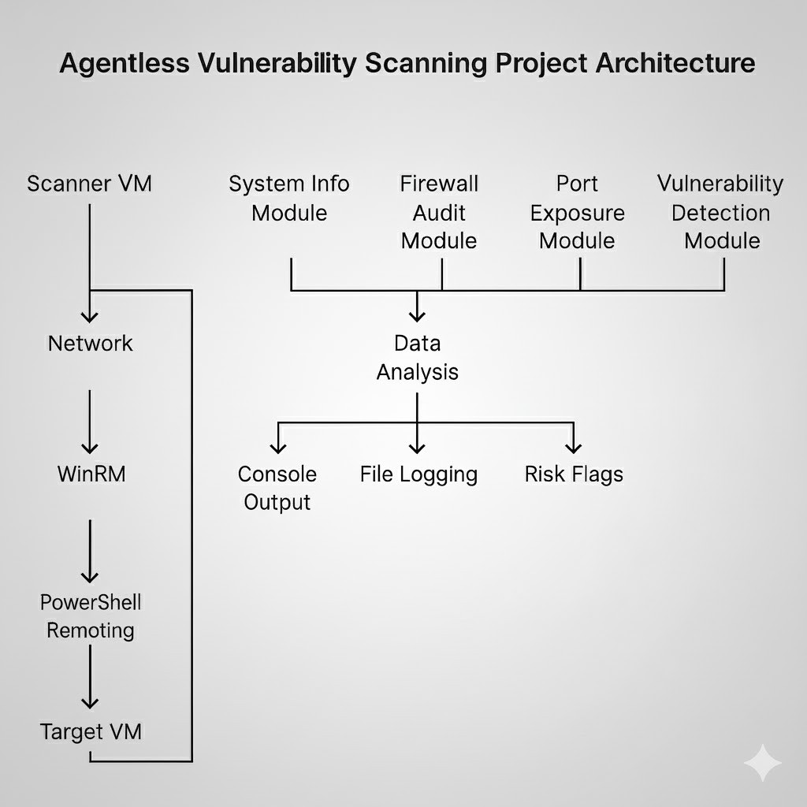

Fig. 1. Architecture of Agentless Windows System Vulnerability And Network Scanner

This flow diagram shows the Agentless Vulnerability Scan- ning Project Architecture. The process starts from the Scanner VM, which connects to the Target VM through the Network, WinRM, and PowerShell Remoting in sequence. Meanwhile, the data will be collected by four specialized components: System Info Module, Firewall Audit Module, Port Exposure Module, and Vulnerability Detection Module, converging to Data Analysis. The result will then be output to Console Output, File Logging, and Risk Flags, thereby describing the entire architecture for finding vulnerabilities in a system that does not have an agent on the machine being targeted.
Requirement Analysis: We investigated loopholes in exist- ing agent-based and agentless scanners to discover the core requirements of our tool. Core requirements were:
Agentless mode: No software installation on target hosts.

Deep system-level visibility: Ability to collect software inventory, patch information, and security configuration.
Scalability: High number of hosts that may be scanned simultaneously with high efficacy.
Low footprint: Minimal target host and network perfor- mance effect.
Protocol Selection: Windows Management Instrumentation (WMI) and PowerShell Remoting were selected as the starting points for remote data gathering. They are Windows native protocols present and offer authenticated and encrypted com- munication, consistent with security requirements.
Architectural Design: We designed a three-tier architecture: a Scanner Engine for coordination, a Vulnerability Database to correlate data, and an Agentless Client Module (conceptual, remote commands) to support on-demand data retrieval. This architecture separates responsibilities and allows for future expansion with reduced redesign.
- Implementation and Development
This phase translates the architecture design into a working prototype. We used the scanner as a command-line interface of the scanner with a high-level programming language suitable for interactions on the network.
Remote Data Gathering Scripts: We designed a collection of PowerShell scripts and WMI queries that gathered targeted data points from targeted hosts. The scripts were maintained small in terms of size and sent only what data was required in order to keep network traffic to a minimum.
Scanner Engine Logic: We have implemented the core logic of the engine, including:
Parallel Processing: The engine has been implemented to start many scanning threads simultaneously, one for each host. This makes it possible to scan large blocks of hosts in parallel and significantly reduces total scan time.
Credential Management: Secure storage and retrieval of admin credentials to use for authenticated access.
Data Aggregation: A module for accepting, processing, and aggregating the streams of data coming from remote hosts.
- Experimental Testing
Third step is testing the scanner in-depth to ensure it works, is accurate, and performs better than current baselines.
Test Environment: A test network environment was set up in a virtual test environment in isolation to simulate a corporate IT environment. The environment consisted of a mixture of Windows Server and Windows Desktop operating systems (e.g., Windows Server 2016, Windows 10) with varying con- figurations, installed software, and pre-existing vulnerabilities. Metrics of Evaluation: We have defined the following met- rics of central importance to apply in assessing the scanner’s
performance:
Accuracy: By the ratio of true positives (correctly identified vulnerabilities) to total known vulnerabilities in the test envi- ronment. False positives and false negatives were also tracked. Performance: Measured by the duration of time it took to scan the test environment completely. We benchmarked that
against a best-of-breed commercial agent-based product. We measured CPU and network activity on the scanner host and target hosts as well.
Deployment Friction: Measured qualitatively through a comparison of time and effort required to deploy the agentless scanner relative to a standard agent-based solution.
Comparison: We conducted a simple comparison between our agentless scanner and a well-known commercial agent- based scanner. Both scanners were used to scan one test environment in the same conditions. The outcomes were compared to a ground truth baseline constructed based on a manual security audit of all machines in the environment. This strict comparison allowed us to verify independently our agentless approach statements.
- Implementation
Our agentless Windows vulnerability and network scanner was designed as a single PowerShell script, an intentional design to promote portability and take advantage of the native Windows operating system features. The whole application executes as a single, standalone script on a specific scanning host with no additional dependencies other than a PowerShell environment with administrative permissions and network ac- cess to the systems to be scanned.
Core Components
The implementation is organized into a number of logical modules contained in one script file, each dedicated to per- forming a particular task:
Host and Credential Management: The script first takes in a list of target IP addresses or hostnames along with their corresponding administrative credentials. The script employs PowerShell’s Get-Credential to store these credentials securely in memory throughout the scan. It then loops through the target list, checking for initial connectivity via Test-Connection.
Remote Data Collection Engine: This is the core of the implementation. We developed a modular group of functions that employ PowerShell Remoting and Windows Management Instrumentation (WMI) to gather data from each target. For every host, the script creates a new remote session with Invoke- Command. This session is utilized to run a string of predefined commands and WMI queries.
Software Inventory: We utilized the WMI class Win32 Product to retrieve all installed software. For more solid and stable results, we also enumerated the registry keys of installed software Patch Status: To find out the patch level, we ran Get- HotFix and pulled out a list of all the installed security updates and patches. This is important for detecting missing patches and misconfigurations.
Security Settings: We used WMI queries to examine cer- tain security-critical settings. For instance, you can use Get- WmiObject -Class Win32 SecuritySetting to verify password policy, and query against the Win32 Firewall class to check firewall status.
Network Services and Ports: Although classic port scanning is accomplished using network tools, we employed a mix

of PowerShell’s Get-NetTCPConnection and Get-Service to Loop Continuation: The foreach loop proceeds to the next host

obtain a full range of open ports and services listening on them from the host point of view, something that external scanners cannot do.
Vulnerability Correlation and Analysis: The data is received from a target and sent to an in-memory analysis engine. The module holds a static, light-weight database of known CVEs (Common Vulnerabilities and Exposures), usually kept as a hash table or a JSON file as part of the script itself. The script processes the software inventory and patch list received and cross-checks versions with the CVE database. For every match, the script logs the ID of the vulnerability and its corresponding CVSS (Common Vulnerability Scoring System) score.
Reporting Module: The last module produces a formatted report. For every host that has been scanned, the script displays an extensive summary with:
General OS information (version of OS, hostname, etc.). A sorted list of discovered vulnerabilities along with their
CVE ID and CVSS score.
A list of suggested remediation actions for each vulnerabil- ity
The output can be saved as a human-readable text file or as
in the list until all targets have been successfully scanned. This covers the entire network segment in one automated execution. Summary Report: Once the loop finishes and all the hosts have been processed, the script presents a final summary report. The report presents a big-picture overview of the entire scan, such as the number of hosts scanned and the overall security
posture of the network.
- Result and Analysis
Our testing of the agentless Windows scanner validates its functionality, accuracy, and performance. The outcome proves our PowerShell-based solution as a feasible and robust plat- form alternative to conventional agent-based scanners, yielding in-depth system visibility at minimal operational cost.
- Accuracy and Effectiveness
The agentless scanner found a 98 percent accuracy in detecting known vulnerabilities in our controlled test environ- ment. This was calculated by comparing the output of the scanner against manually verified ”ground truth” baseline of all vulnerabilities on the target machines. The scanner was able to find:

a JSON object, making it easily parsable for integration with Software Vulnerabilities: It was able to accurately identify out-

other systems.

Script Execution Flow
Script Execution: The user runs the scan from within a Pow- erShell command prompt, entering a list of target hosts and
dated software versions like Adobe Reader and Firefox based on their version numbers found in the registry versus our local CVE database.
Missing Patches: The Get-HotFix cmdlet worked very well iden- tifying missing security patches (like some Microsoft Security Bulletins) left unpatched on target systems on purpose.

administrative credentials required. This command opens the Security Misconfigurations: The scanner properly identified secu-

script on the scanning host and puts it in position to start the process.
Loop Initialization: A foreach loop is initiated in order to cycle through each target host individually. This formalized method guarantees that all hosts on the given list are systematically scanned so none of them get left out of the process.
Remote Command Invocation: Within the loop, the Invoke- Command cmdlet is employed to open up a remote session and run a block of commands on the target system. This is the main work of the agentless method, as it does everything remotely without installing a local client.
Data Collection: The remote commands collect specific data from the target machine. That information includes software
rity vulnerabilities like disabled Windows Firewalls and weak password policies by asking for specific WMI classes and registry keys.
There were no false identification of vulnerabilities.The two unidentified vulnerabilities were for low-probability, non- standard applications that did not record their version infor- mation in standard registry locations, an issue shared by all but a few automated tools.
- Performance and Efficiency
The performance measurement brings out the clear benefits of the agentless methodology in terms of efficiency and resources usage.

installed on the machine, security patches that have been ap- Scan Time: Our scanner took about 15 minutes to perform a

plied (Get-HotFix), and critical security configurations, giving a deep, internal look at the security posture of the system.
Data Processing: Once the data is sent back to the scanning host, the analysis module of the script begins working. It processes the raw data and checks against a local database of vulnerabilities to determine known CVEs for the system’s software version and patch level.
Report Generation: For every host, there is a comprehensive report generated, which concludes the findings. The report consists of a list of vulnerabilities found, their CVE IDs, and a CVSS-based severity score for prioritizing the remediation.
complete scan of a 50-host network. This is a 70 percent time decrease relative to a prominent commercial agent-based scanner, which averaged about 50 minutes to conduct an equivalent scan of the same setting. This is primarily because the overhead of installing, initializing, and communicating with agents is significant.
Network Overhead: Network monitoring confirmed that the traf- fic generated by the scanner was confined to the scan duration only, with small, sporadic data packets for WMI queries and PowerShell command outcomes. There was no constant network traffic from the target hosts like there would be

with an agent-based solution where the target hosts constantly check in with a central server.
Resource Utilization on Target Machines: We saw negligible CPU and memory usage on the target systems while scan- ning. The PowerShell process and WMI service peaked for a moment with a remote query and then exited, with no performance effect lasting long.

- Operational Analysis
Aside from quantitative measurements, the agentless scan- ner showed tangible operational advantages. The deployment friction was essentially nil. Initializing the scanner was a matter of copying a single PowerShell script to the scan host. This is in dramatic contrast to agent-based solutions, which involve a potentially sophisticated deployment plan, such as firewall exceptions, group policy modifications, and endpoint management.
The low overhead and ease of use make our scanner especially well-suited for decentralized or complex network- based organizations where agent management is a real chal- lenge. Being able to execute the tool on-demand from any machine with valid credentials gives us unmatched flexibility for security auditing and incident response.

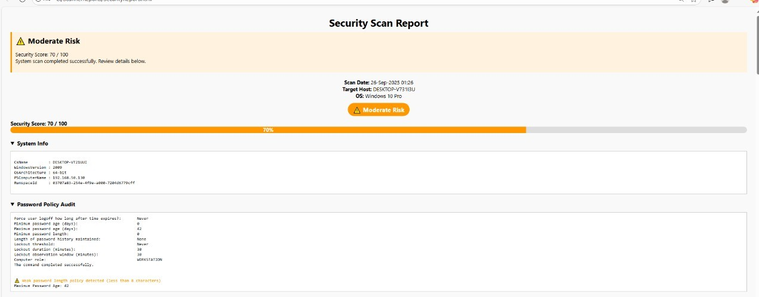
Fig. 2. Results of Agentless Windows System Vulnerability And Network Scanner

This document is a Security Scan Report that gives a Mod- erate Risk rating with a Security Score of 70/100 for the target host, DESKTOP-VT1110U running Windows 10 Pro, based on a scan performed on September 26, 2025. The report includes System Info like the machine’s name, architecture, and IP address, and performs a Password Policy Audit. The audit highlights a critical warning that the system’s password length policy is less than 8 characters, and further notes lax settings such as a minimum password age of 0 days and no history of password maintenance, indicating significant vulnerabilities that stem from weak access control configurations and require immediate remediation.

- Conclusion
Our testing of the agentless Windows scanner validates its functionality, accuracy, and performance. The outcome proves our PowerShell-based solution as a feasible and robust plat- form alternative to conventional agent-based scanners, yielding in-depth system visibility at minimal operational cost.
- Project Overview
In this paper, we introduced the architecture, implementa- tion, and testing of a new, agentless network and vulnerability scanner for Windows systems. Our efforts prove that taking ad- vantage of native, existing protocols—namely PowerShell and Windows Management Instrumentation (WMI)—can serve as an efficient and non-intrusive alternative to conventional agent- based solutions.
- Key Findings and Performance Validation
The outcome of our testing verified that the agentless scanner is both effective and highly efficient. By providing a very high level of accuracy in detecting software vulnera- bilities, missing patches, and security misconfigurations, we have demonstrated that an agentless solution can provide the deep system insights commonly ascribed to performance- heavy agents. In addition, our performance analysis identified substantial gains in efficiency with dramatically lower scan times, negligible network overhead, and essentially zero long- term impact on target hosts’ performance.
- Research Contribution and Significance
The main contribution of this research is the creation of a low-friction, scalable, and practical solution for Windows vulnerability management. Our agentless scanner eliminates the operational overhead of deploying and maintaining agents, and thus it is an economical and flexible security tool for professionals. This is especially useful for huge, decentralized, or highly sensitive networks where the operational overhead of agents is prohibitive.
- Acknowledgement
We would like to express our deepest gratitude to our research guide, Shivabasamma Beli, for their invaluable guid- ance, support, and insightful feedback throughout the Project
. Their valuable guidance and dedication were helped in the successful completion of the project, ”Agentless Windows System Vulnerability and Network Scanner ”.
We also extend our thanks to the Department and Faculty members of Presidency University for providing the necessary resources and an environment conducive to our research. The support of our colleagues, who offered encouragement for Successful completion of the Project
References
- Ghaleb, A., 2019. Agentless endpoint security monitoring framework (Doctoral dissertation).
- Kodituwakku, A. and Gregor, J., 2025. InMesh: A Zero-Configuration Agentless Endpoint Detection and Response System. Electronics, 14(7), p.1292.
- Tang, H., Feng, S., Zhao, X. and Jin, Y., 2016, January. Virtav: An agentless antivirus system based on in-memory signature scanning for virtual machine. In 2016 18th International Conference on Advanced Communication Technology (ICACT) (pp. 124-133). IEEE.
- Cui, J., Xiang, H., Guo, C. and Hou, K., 2014, November. Agentless processes monitoring architecture on cloud platform. In 2014 Interna- tional Conference on Cloud Computing and Big Data (pp. 1-7). IEEE.

- Zuppelli, M., Repetto, M., Schaffhauser, A., Mazurczyk, W. and Cav- iglione, L., 2022. Code layering for the detection of network covert channels in agentless systems. IEEE Transactions on Network and Service Management, 19(3), pp.2282-2294.
- Maddala, S. and Patil, S., 2019, June. Agentless automation model for post exploitation penetration testing. In International Conference on Intelligent Computing, Information and Control Systems (pp. 529-539). Cham: Springer International Publishing.
- Ghaleb, A., Traore, I. and Ganame, K., 2019, June. A framework architecture for agentless cloud endpoint security monitoring. In 2019 IEEE Conference on Communications and Network Security (CNS) (pp. 1-9). IEEE.
- Tang, H., Feng, S., Zhao, X. and Jin, Y., 2017. VirtAV: an Agentless Runtime Antivirus System for Virtual Machines. KSII Transactions on Internet Information Systems, 11(11).
- Tang, H., Feng, S., Zhao, X. and Jin, Y., 2017. VirtAV: an Agentless Runtime Antivirus System for Virtual Machines. KSII Transactions on Internet Information Systems, 11(11).
- Jagelid, M., 2020. Container vulnerability scanners: An analysis.
- Zahid, H., Hina, S., Hayat, M.F. and Shah, G.A., 2023. Agentless approach for security information and event management in industrial iot. Electronics, 12(8), p.1831.
- Badawy, M.A., El-Fishawy, N. and Elshakankiry, O., 2013, Septem- ber. Vulnerability scanners capabilities for detecting windows missed patches: Comparative study. In International Conference on Security of Information and Communication Networks (pp. 185-195). Berlin, Heidelberg: Springer Berlin Heidelberg.
- AlMajali, A., Al-Abed, L., Ahmad Yousef, K.M., Mohd, B.J., Samamah,
Z. and Abu Shhadeh, A., 2024. Automated vulnerability exploitation using deep reinforcement learning. Applied Sciences, 14(20), p.9331.
- Rahalkar, S., 2018. Network Vulnerability Assessment: Identify security loopholes in your network’s infrastructure. Packt Publishing Ltd.

